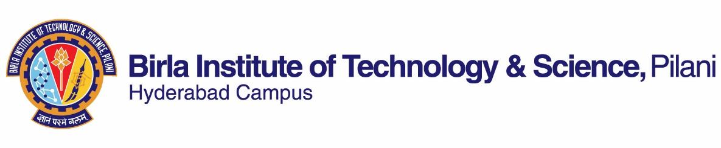

**FIRST SEMESTER 2022-2023**

# Course Handout Part II

Date: 29-08-2022

In addition to part-I (General Handout for all courses appended to the time table) this portion gives further specific details regarding the course.

*Course No.* : HSS C316/ HSS F316

## Course Title : Popular Literature and Culture of South Asia

## Instructor-in-Charge : Dr. Maya Vinai

**Scope and Objective of the Course:** The objective of the course is to introduce students to Literature and Popular Culture of South Asia. In doing so, it will familiarize students to perspectives and scenarios that differ from their own culture, thereby, helping them to have deeper understanding of other cultures. This course aims to bridge the gaps in our understanding of our neighbors and enable us to have broader perspectives

**Textbooks:**

1. Betts, Raymond & Lyz Bly F. *A History of Popular Culture (2nd edition).* New York: Routledge, 2013.

**Reference books**

1. Daniyal Mueenuddin. *In other rooms and other wonders*. New York: W.W Norton and Company, 2010.
2. Hashmi Nadia. *The Pearl that broke its Shell.* New York: Harper Collins, 2014.
3. Hosseini Khalid. *And the Mountains Echoed.* London: Bloomsbury, 2014.
4. Narula, Devika Khanna*. South Asian Diaspora: Sumer Blossoms in Winter Garden.* New Delhi: Cr New Delhi: Creative, 2005.
5. Unnikrishnan Deepak. *Temporary People.* New Delhi, Penguin: 2017
6. Vora, Neha. *Impossible Citizens.* New Delhi: Orient Blackswan, 2013
7. Zaman, Niaz. *Literature in Bangladesh: Selected Short Stories from Bangladesh.* Dhaka: UPL, 2007.
8. Chambers, Claire. *Desi Delicacies: Food Writing from muslim South Asia.* New Delhi: Picador, 2013.

**Web Sources:**

https://core.ac.uk/download/58757146.pdf

**Course Plan:**

| **Lecture No.** | **Learning Objectives** | **Topics to be covered** | **Chapter in the Text Book** |
| --- | --- | --- | --- |
| 1 | Introductory Class | Introduction to the paper | Class Notes |
| 2-6 | Examine the political, social, cultural and economic configuration of South Asian countries. | South Asia as a region  Geographical boundaries, political, economic and societal features.  Major religious diversities of these South Asian countries.  The connotations of the term ‘popular culture’ & its features. | Reading Material.  (T.B Chapter 1 & 2) |
| 7-13 | Analyze and interrogate the racial stereotypes. | The concept of ethnic majority and minority, power divide and unequal distribution of resources  Understanding Afghanistan through literature | Selected Excerpts from R.B 3. |
| 14-20 | Analyze the representational strategies post 9/11 attacks | The politics of representation and breaking of stereotypes.  Understanding Pakistan through literature and select advertisements.  Media Framing, Islamaphobia & the creation of East-West Binary | Selected Readings- Mohsin Hamid’s *The Reluctant Fundamentalist*  (R.B 1) |
| 21- 26 | Examine partition and trauma of dislocation in fiction. | Violence, migration and dislocation.  Understanding the partition of 1947 and the liberation war of 1971 through Bangladeshi literature. | (R.B 7) |
| 27-32 | Discuss the concept of nation- building in films | Culture and its representation through literature and cinema. Nation/ Desh Videsh dichotomy and the representation of NRI in Bollywood and South Asian cinema and fictional works. | Class notes and handouts. |
| 33- 38 | Discuss the ethnic divide (Sinhala- Tamil) and subversion of binaries. | Identity Formation and Assertion  Commonalities in spite of all the differences Food, culture, the gulf experience, and rituals | (R.B – 8)  Selected short stories/excerpts from India, and Sri Lanka. |
| 39-42 | Analyze marginalization on account of ethnicity and gender and resistance by the subalterns. | Bringing in marginalized voices &  Writings by women  Poems from Afghanistan  Culture, Festivities, women in private and public sphere | Selected South Asian Films & Advertisements  &  Class Notes |  |  | Selected *Landays* |

**Evaluation Scheme:**

|  |  |  |  |  |
| --- | --- | --- | --- | --- |
| **Component** | **Duration** | **Weightage (%)** | **Date & Time** | **Nature of Component** |
| Assignment/ Quiz/ Presentations (2) | 40 minutes | 30 | Will be Announced | Open Book |
| Mid Semester Exam | 90 minutes | 30 | 03/11 1.30 - 3.00PM | Closed Book |
| Comprehensive Exam | 3 hours | 40 | 26/12 AN | Closed Book |

**Chamber Consultation:** Consultation hours will be announced in the class and shared on the CMS

**Notices:** Will be put up on CMS//alternative learning management system

**Make-up Policy**: Make ups will be granted only for exceptionally deserving cases and should be communicated at least 2 hours before the missed component along with sufficient evidence.

**Academic Honesty and Integrity Policy:** Academic honesty and integrity are to be maintained by all the students throughout the semester and no type of academic dishonesty is acceptable.

**Dr. Maya Vinai**

**INSTRUCTOR-IN-CHARGE**